Lab 20 cron job

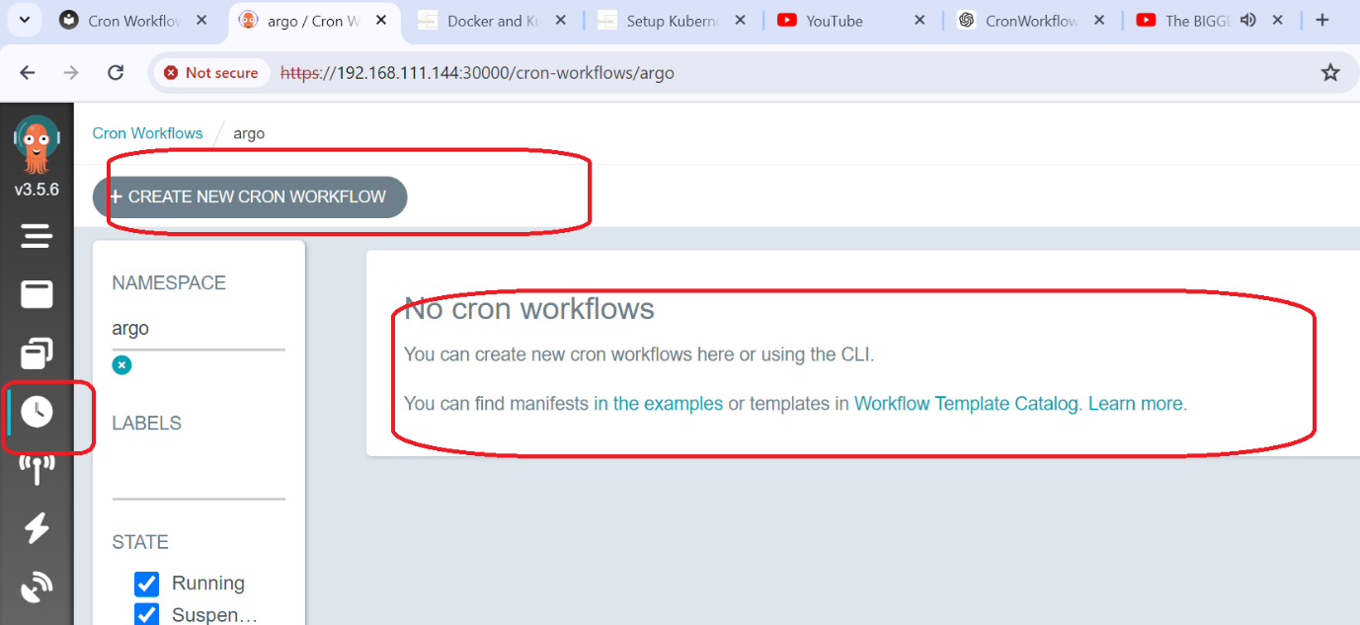

apiVersion: argoproj.io/v1alpha1

kind: CronWorkflow

metadata:

name: test-cron-wf

spec:

schedule: "\* \* \* \* \*"

concurrencyPolicy: "Replace"

startingDeadlineSeconds: 0

workflowSpec:

entrypoint: whalesay

serviceAccountName: training

shutdown: Terminate

timezone: Asia/Kolkata

templates:

- name: whalesay

container:

image: alpine:3.6

command: ["sh", "-c"]

Lab 2:

argo cron create argo-cronjob.yaml

argo cron list -n argo

argo cron get test-cron-wf-1 -n argo

argo cron suspend test-cron-wf-1 -n argo

argo cron list -n argo

yaml file

apiVersion: argoproj.io/v1alpha1

kind: CronWorkflow

metadata:

name: test-cron-wf-1

namespace: argo

spec:

schedule: "\* \* \* \* \*"

suspend: false

concurrencyPolicy: Allow

startingDeadlineSeconds: 0

successfulJobsHistoryLimit: 3

failedJobsHistoryLimit: 1

workflowSpec:

entrypoint: whalesay

serviceAccountName: training

shutdown: Terminate

templates:

- name: whalesay

container:

image: alpine:3.6

command: ["sh", "-c"]

args: ["date; sleep 90"]